Adam Cook

03/03/15

**Testing for TME Enhancement: Addition of the Program Scope**

Projects Drop Down List:

I have made edits to multiple modals in the Projects Drop Down List on the TME NavBar to include a Program Scope. These particular edits are listed below as well as how to test these edits.

1. “Create” – When you select Create from the “Project” Drop Down List on the TME NavBar, a new option is available which allows a person to select a Program for the Project. This selection is not necessary. For Testing, I would recommend creating two new Projects. One with a Program and one without a Program.

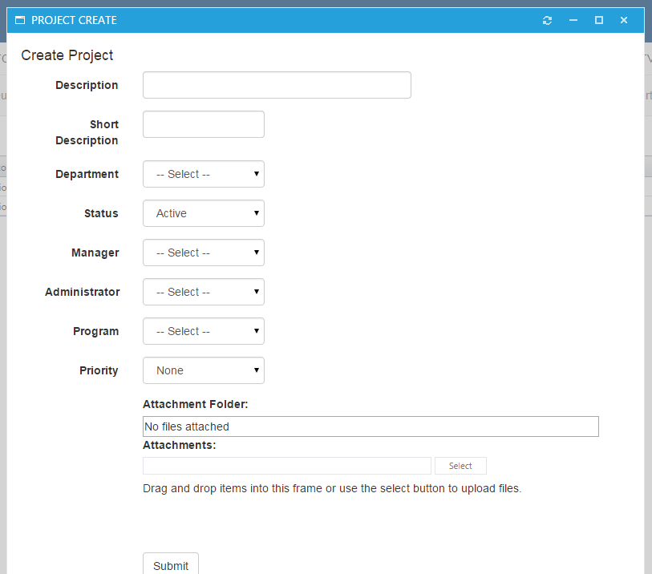

1. “Edit Project” – Users with permission are able to edit Projects three ways. By selecting “All” from the Projects Drop Down List, by searching for a Project using the “Search” option in the Projects Drop Down List, and also from selecting a particular Project Manager from the Projects Drop Down List. All of these items can be tested by using these three methods to edit a Project. With these three edit options, a new “Program” drop down list should be available for each modal. For Testing, I would recommend editing Projects these three ways, by adding a Program to a Project and removing a Program from a Project with all these methods.

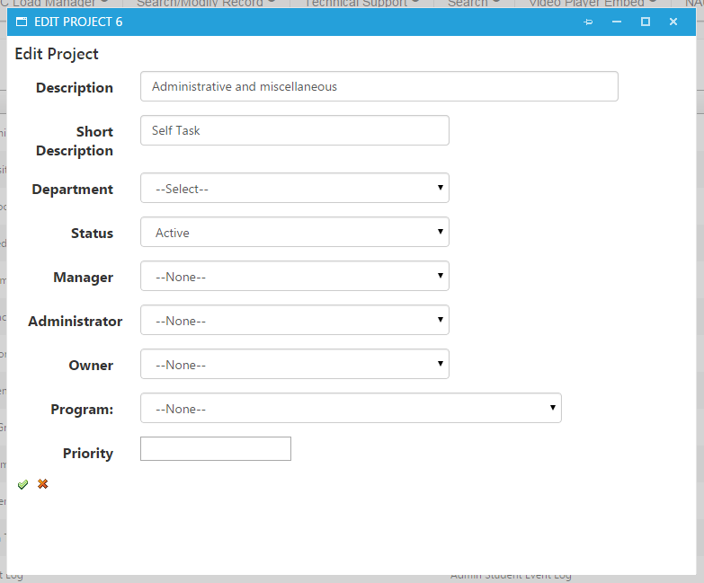

Programs Drop Down List:

I have added a new Drop Down List to the TME NavBar titled “Program”. This Drop Down List mimics the “Project” Drop Down List in that it has a “All”, “Create”, and “Search” functionalities. Instead of a list of Project Managers, the new Drop Down List has a list of Programs. When you click a Program a list of Projects appear that are assigned to that program. I will list my additions and edits in order of the Drop Down List.

1. “All” – When you select “All”, all programs should appear. The Programs will have a View Milestones Button, their Title, their Scope, and their Status. I omitted the Program ID from each Program because the Projects didn’t have their IDs listed on them. Also, there is a hidden column that will become visible if the user has permission to edit the Program. As of current, the permission is identical to the permission necessary to edit Projects. Testing should include editing a Program in all three of its properties currently editable in the edit Program modal.

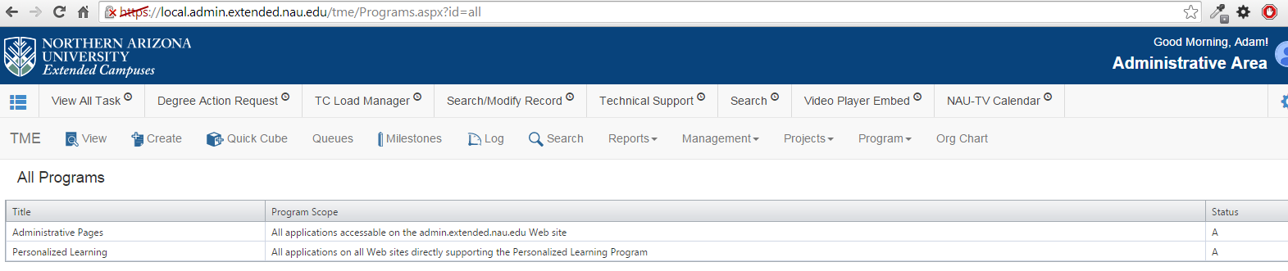

1. “Create” – When you select “Create” from the Programs Drop Down List, a Create Program modal should appear. This modal should include all three properties for a Program (Title, Program Scope, and Status). This create feature should be tested by creating a new program using this modal. 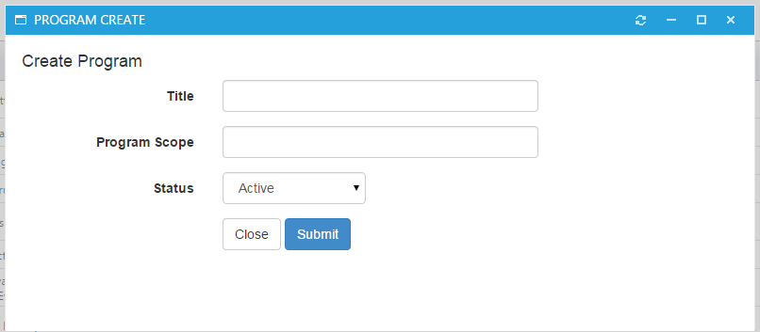
2. “Search” – When you select “Search” from the Programs Drop Down List, a modal will appear that is similar to the Project Search modal. This will allow a person to search programs with a text box and edit to look for Programs that are Active/Inactive/All. When you search for a Program, a new page should appear listing the search results. The records should include their Titles, Program Scopes, and Statuses. Users with permission will also be able to edit Programs. Test should be run to make sure that the search results are appropriate for the query. Also, there needs to be a test for the modal to make sure it edits Programs properly.

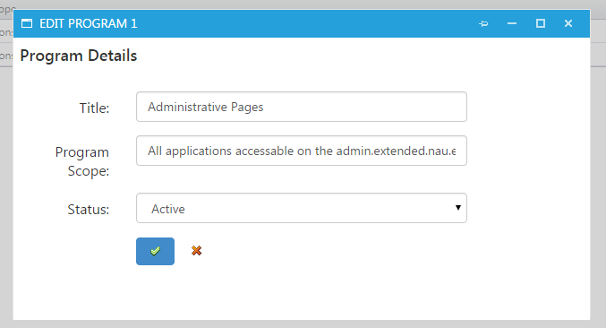

Milestones:

I have added functionality which now allows a user to search through projects and their milestones based off of programs. This particular search functionality is only visible when you click a milestone through the Programs page.

1. Make sure all sorting functions work correctly and test to make sure that the proper projects and proper milestones are coming up with the associated program.

